Continuing Education Certificate

This is to certify that

(Name of participant or attendee)

has attended and successfully completed the educational activity

Eleventh Annual
Pharmacology Conference
Sponsor: North Dakota Nurse Practitioner Association

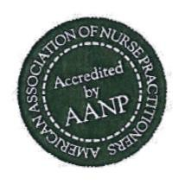
This activity is approved for 14.5 contact hours of continuing education (which includes 12.10 hours pharmacology) by the American Association of Nurse Practitioners.

This activity was planned in accordance with AANP Accreditation Standards and Policies.
Program ID # 19093892

Dr. Adam Hohman

Location: Bismarck, ND 58504 Adam Hohman, DNP, APRN, FNP-BC
Date: September 26-27, 2019 Conference Coordinator
Sponsor: North Dakota Nurse Practitioner Association

